**Project title:**

**UR16e (Rectangle trajectory)**

**Introduction:**

The UR16e is our smaller heavy-duty industrial collaborative robot. When space is limited but you need to handle large and heavy workpieces or objects, the UR16e is the perfect choice.

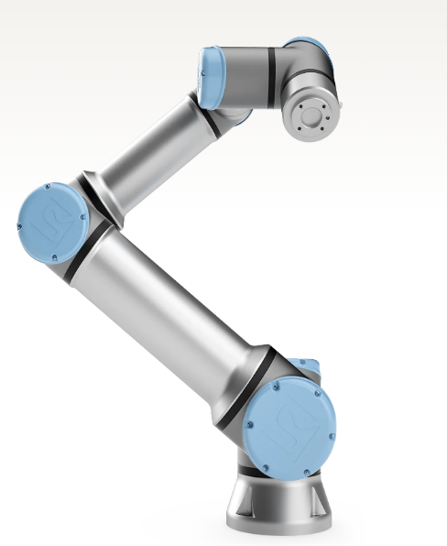

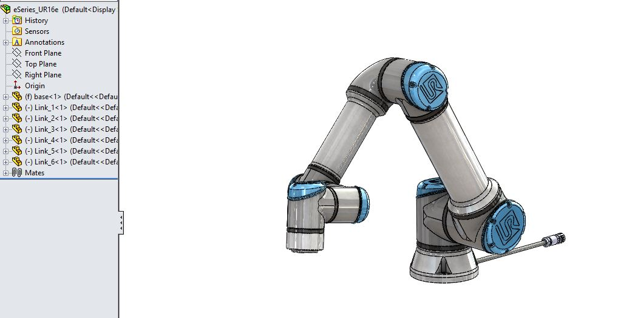**SolidWorks Model:**

**Export in Matlab:**

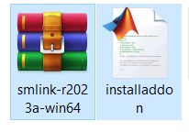 First of all, you have to install multibody Simulink file from the official website. No need to install it I will provide the downloaded file. There are two files one addon and other is Simulink zip file.

**How to install it**:

Following the link, I will give you how to install these.

<https://youtu.be/pDiwAA1cnb0?si=PptjsUXyatFPS74R> (Very important)

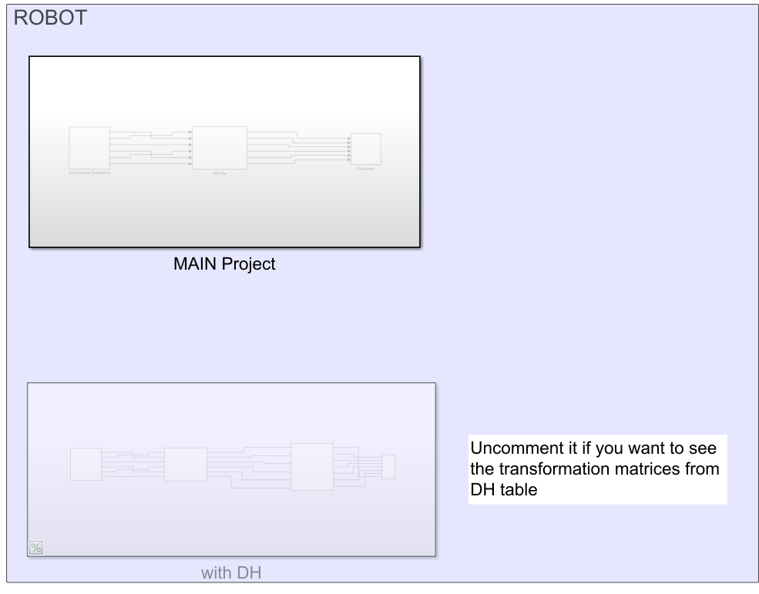**Simulink Model:**

**Import robot in Matlab drom solidworks .xml file using command smimport (‘UR16e.xml’)**

Use the signal editor to give the angles to the robot:

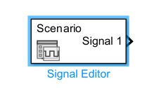

Because we have 6 DOF robot so give six different angles at different time:

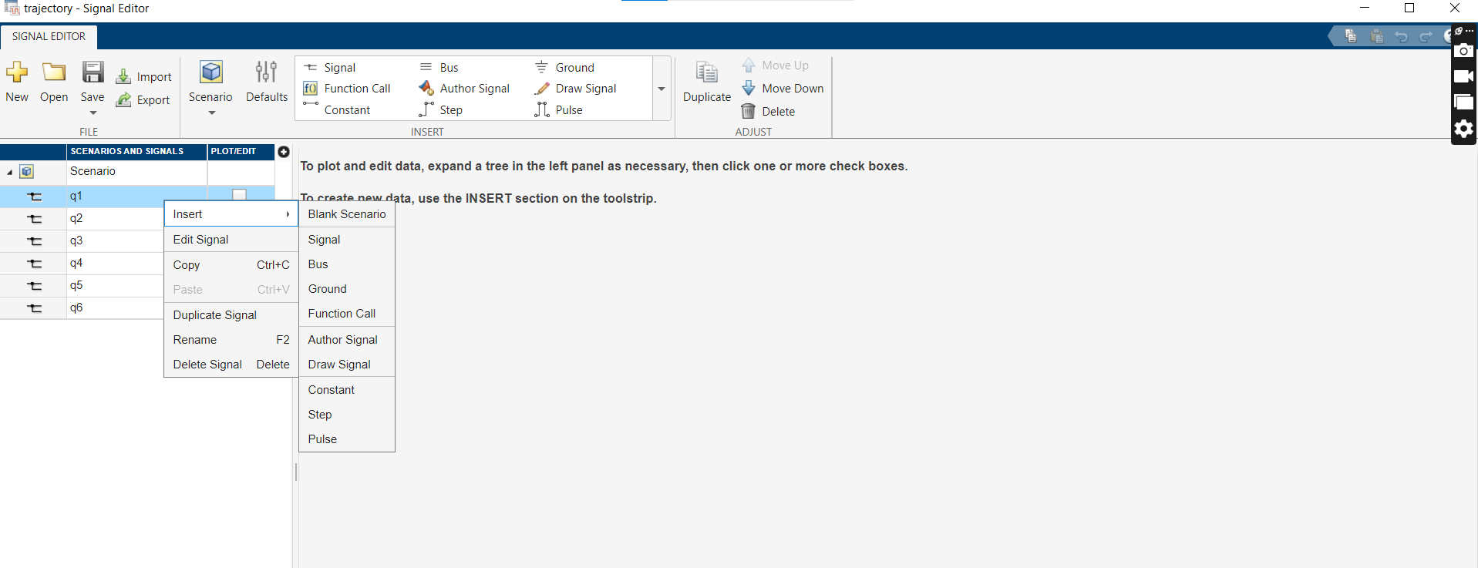

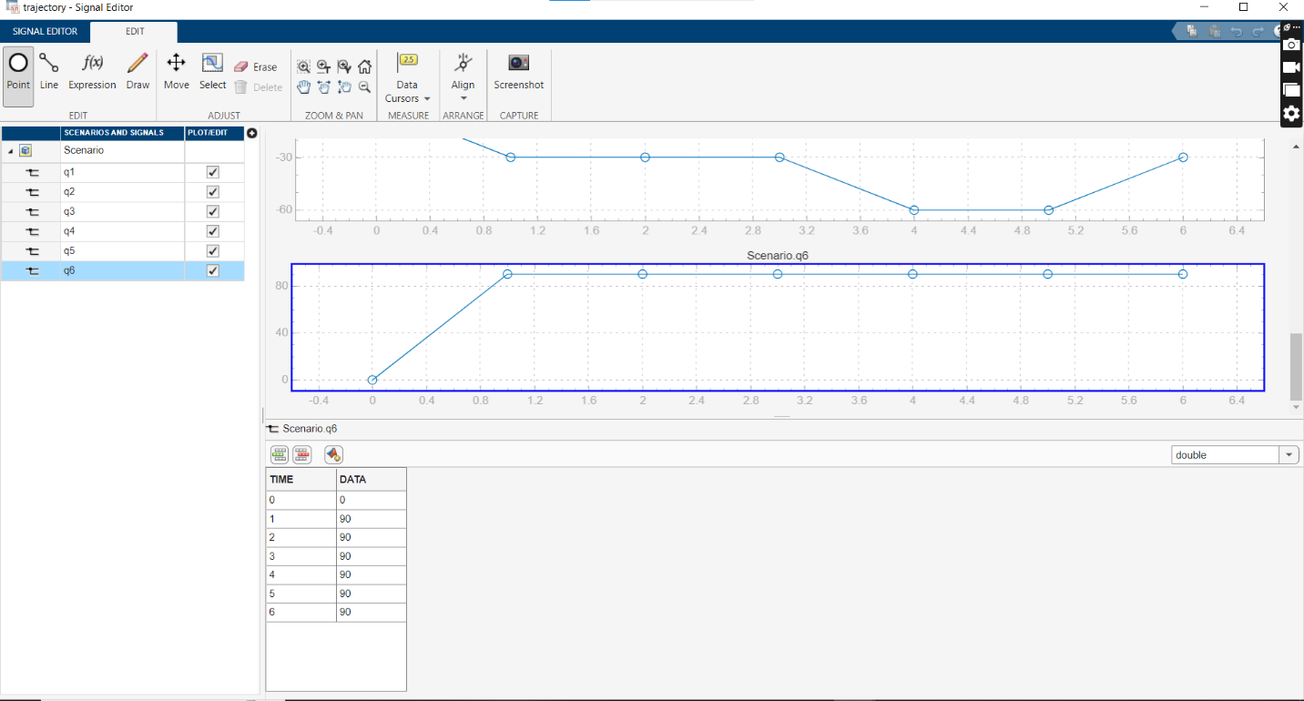insert the black scenario for each q. It will become:

Run the simulation it will give the following results:

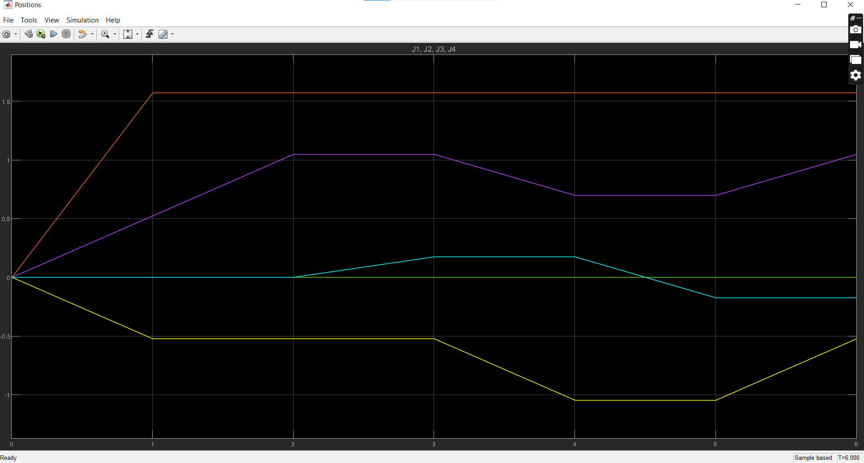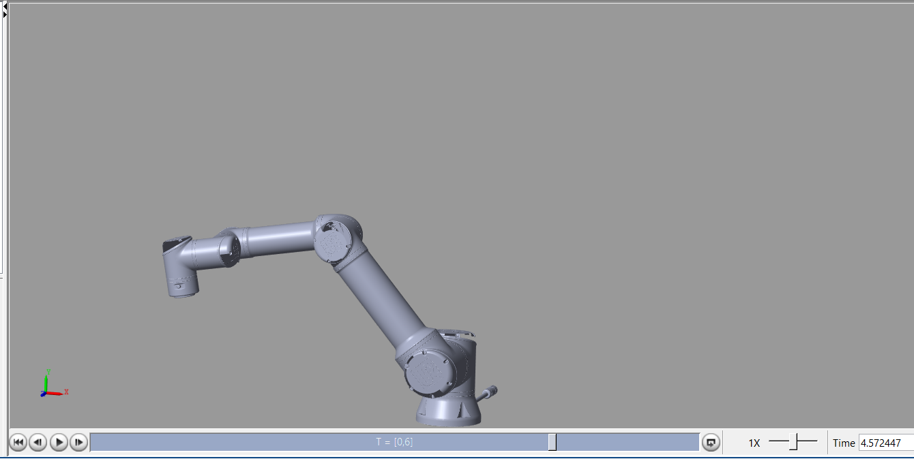

**GUI:**

Following the code is used to make a graphical user interphase it will parse the commands directly to the simulnk:

|  |
| --- |
| function createGUI()  hFig = figure('Name', 'UR16e Control Panel');    uicontrol('Style', 'pushbutton', 'String', 'Start', 'Position', [20, 150, 100, 50], 'Callback', @startCallback, 'BackgroundColor', [0.2, 0.6, 1]);  uicontrol('Style', 'pushbutton', 'String', 'Reset', 'Position', [20, 80, 100, 50], 'Callback', @resetCallback, 'BackgroundColor', [1, 0.2, 0.2]);  uicontrol('Style', 'pushbutton', 'String', 'Pause', 'Position', [20, 10, 100, 50], 'Callback', @pauseCallback, 'BackgroundColor', [1, 0.8, 0]);  uicontrol('Style', 'pushbutton', 'String', 'Resume', 'Position', [20, 220, 100, 50], 'Callback', @resumeCallback, 'BackgroundColor', [0.5, 0.8, 0.5]);  function startCallback(~, ~)  disp('Starting trajectory...');  set_param('eSeries_UR16e', 'SimulationCommand', 'start'); % Original File name in my case it is eSeries_UR16e  end  function resetCallback(~, ~)  disp('Resetting...');  set_param('eSeries_UR16e', 'SimulationCommand', 'stop');  set_param('eSeries_UR16e', 'SimulationCommand', 'start');  end  function pauseCallback(~, ~)  disp('Pausing...');  set_param('eSeries_UR16e', 'SimulationCommand', 'pause');  end  function resumeCallback(~, ~)  disp('Resuming...');  set_param('eSeries_UR16e', 'SimulationCommand', 'continue');  end  end |

